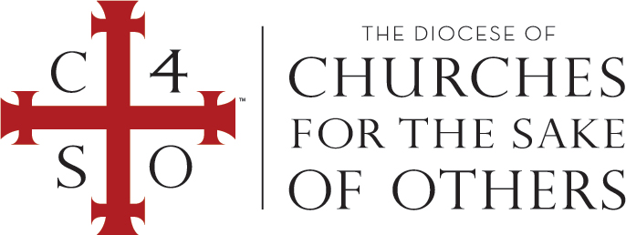

the Sacramental Rite of Confirmation by the laying on of hands

following a renunciation of evil and profession of Jesus Christ as Lord and Savior

in the Diocese of Churches for the Sake of Others

on MONTH DAY, YEAR

at CHURCH in CITY, STATE.

*NAME OF OFFICIATING CLERGY*

*Bishop in the Diocese of Churches for the Sake of Others*

[FIRST MIDDLE LAST NAME]

In the name of the Father, and of the Son, and of the Holy Spirit. Amen.

This is to certify that, after the example of the Apostles and in conformity with the custom of the one holy catholic and apostolic Church in all ages, we did administer to

Certificate of confirmation