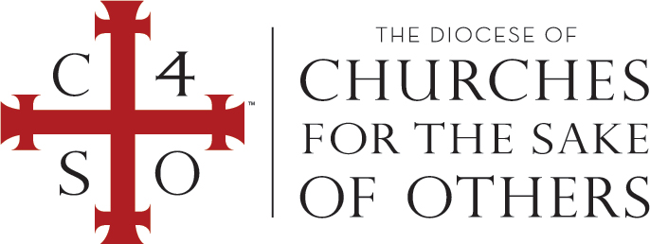

the Sacramental Rite of Baptism according to Christ’s command, by water and

in the Name of the Father, and of the Son, and of the Holy Spirit

in the Diocese of Churches for the Sake of Others

on [MONTH, DAY,YEAR]

at [CHURCH] in [CITY, STATE].

*[NAME OF BISHOP OR CLERGY]*

*[Bishop or Clergy] in the Diocese of Churches for the Sake of Others*

[NAME]

In the name of the Father, and of the Son, and of the Holy Spirit. Amen.

This is to certify that, after the example of the Apostles and in conformity with the custom of the one holy catholic and apostolic Church in all ages, we did administer to

Certificate of BAPTISM