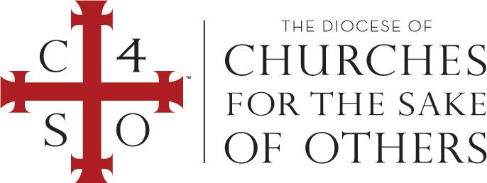

CERTIFICATE OF BAPTISM

IN THE NAME OF THE FATHER, AND OF THE SON, AND OF THE HOLY SPIRIT. AMEN. THIS IS TO CERTIFY THAT, AFTER THE EXAMPLE OF THE APOSTLES AND IN CONFORMITY WITH THE CUSTOM OF THE ONE HOLY CATHOLIC AND APOSTOLIC CHURCH IN ALL AGES, WE DID ADMINISTER TO

DONNA ELENA SMITH

THE SACRAMENTAL RITE OF BAPTISM ACCORDING TO CHRIST’S COMMAND, BY WATER AND IN THE NAME OF THE FATHER, AND OF THE SON, AND OF THE HOLY SPIRIT IN THE DIOCESE OF CHURCHES FOR THE SAKE OF OTHERS
on [MONTH, DAY, YEAR]
at [CHURCH] in [CITY, STATE].

[NAME OF BISHOP OR CLERGY]
(Bishop or Clergy) in the Diocese of Churches for the Sake of Others

