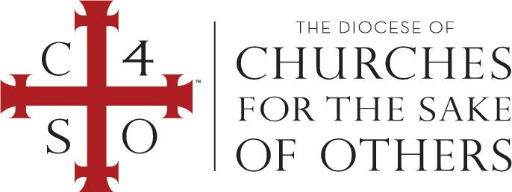

CERTIFICATE OF CONFIRMATION

IN THE NAME OF THE FATHER, AND OF THE SON, AND OF THE HOLY SPIRIT. AMEN.
THIS IS TO CERTIFY THAT, AFTER THE EXAMPLE OF THE APOSTLES AND IN CONFORMITY WITH THE CUSTOM OF THE ONE HOLY CATHOLIC AND APOSTOLIC CHURCH IN ALL AGES, WE DID ADMINISTER TO

LUIS THOMAS KIM

THE SACRAMENTAL RITE OF CONFIRMATION BY THE LAYING ON OF HANDS FOLLOWING A RENUNCIATION OF EVIL AND PROFESSION OF JESUS CHRIST AS LORD AND SAVIOR
IN THE DIOCESE OF CHURCHES FOR THE SAKE OF OTHERS
on [MONTH, DAY, YEAR]
at [CHURCH] in [CITY, STATE].

[NAME OF BISHOP]
Bishop in the Diocese of Churches for the Sake of Others

